Behave BDD is also known as user stories written in plain text.
Create a new Project:
Project Name :BehaveBDD
1.Add Features Package and in it add googlesearch.feature as file
2.Add behave python package.
Inside features package add steps directory.
Create a python file for each steps
Add from behave import * and run the predefined steps.
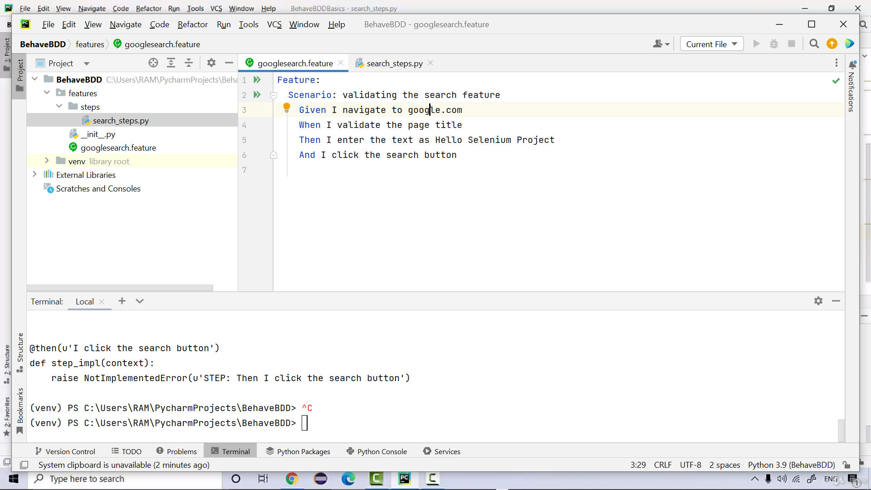
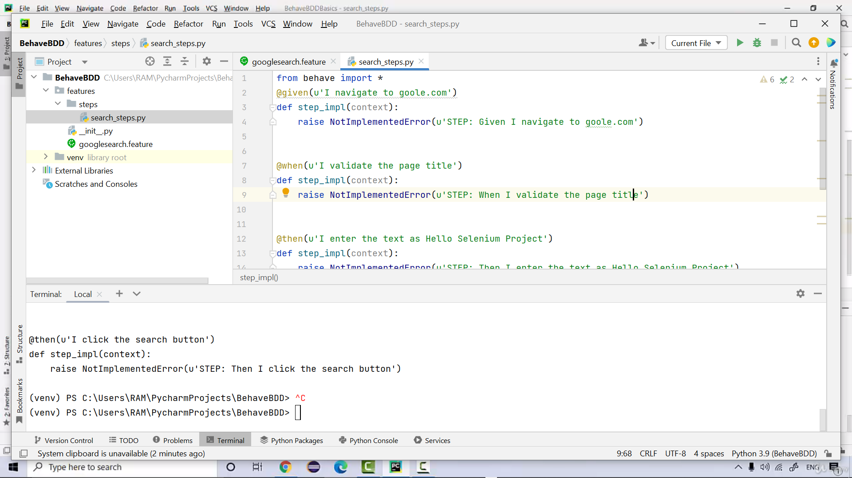
Test Passed
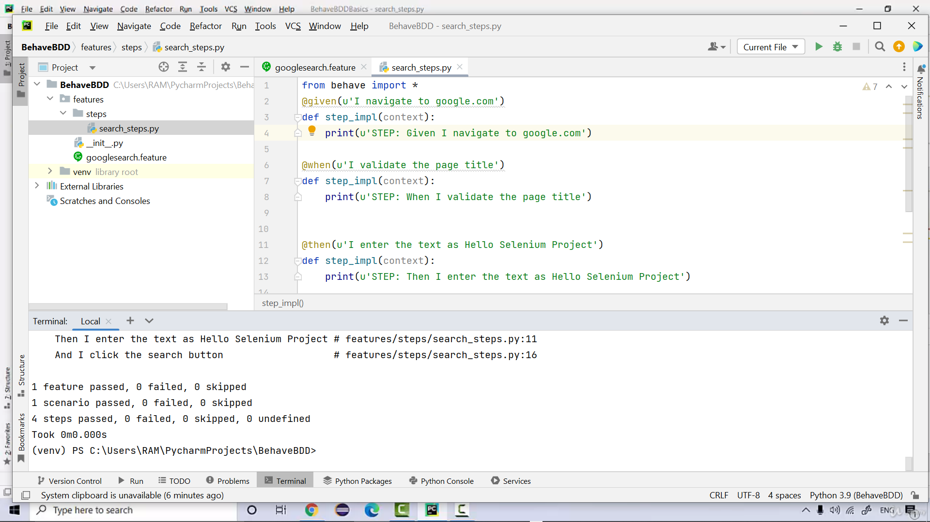
Adding Hooks,Steps and integrating with webdriver.
Def in environment file is called Hooks.It is run for executing common browser loading
Add behave.ini file= for printing data(This file should be created in the root of the project)
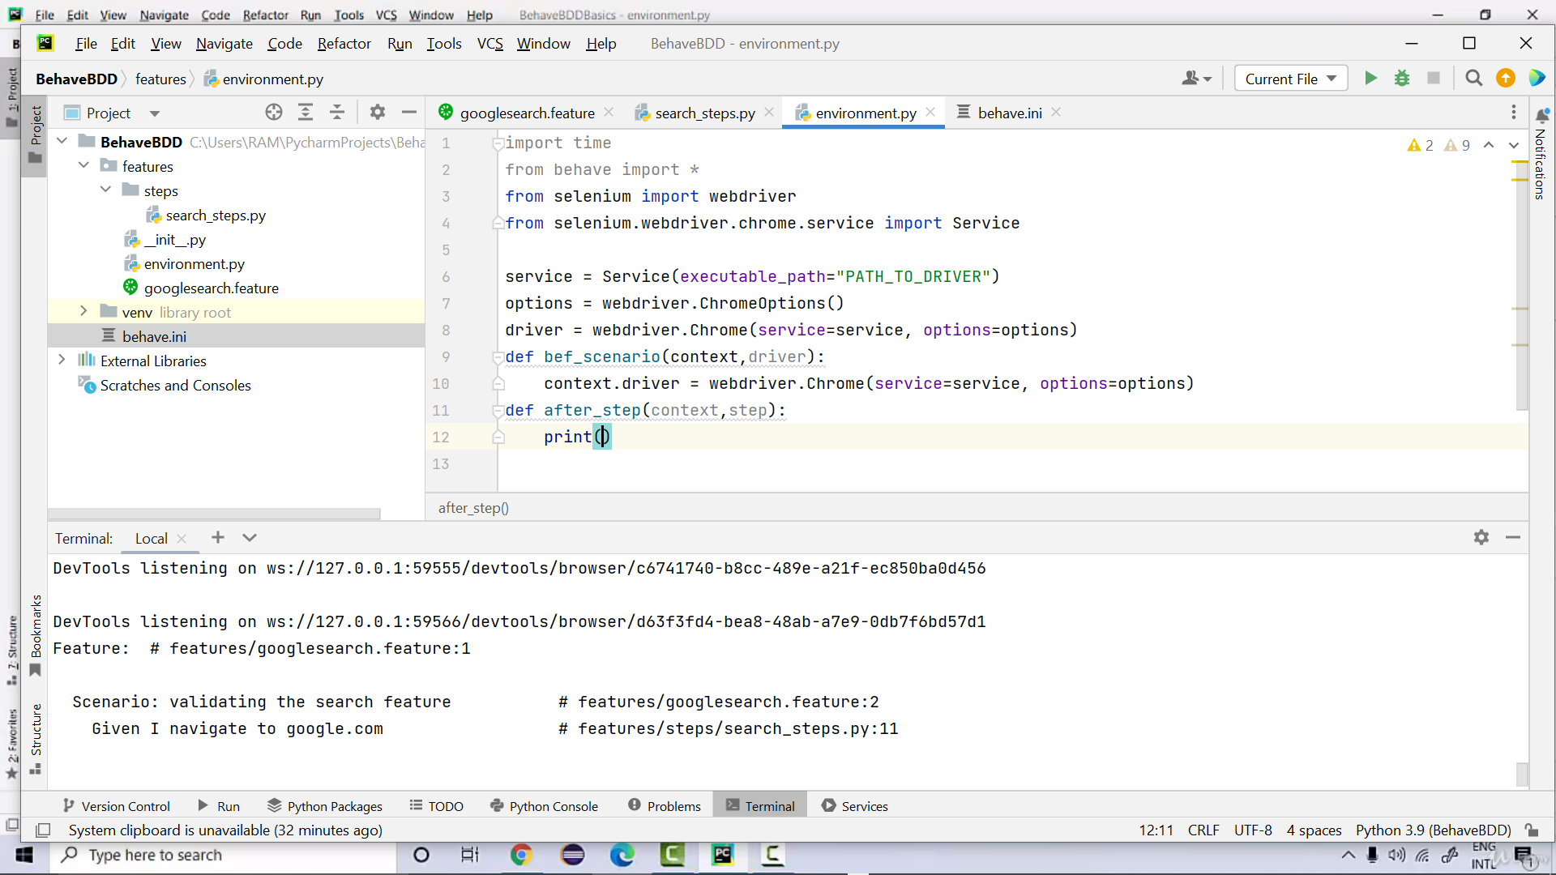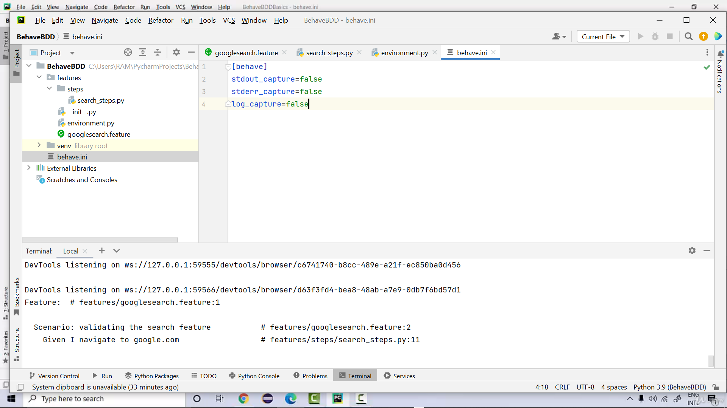

Now we can run for multiple scenarios with slight editing in steps features
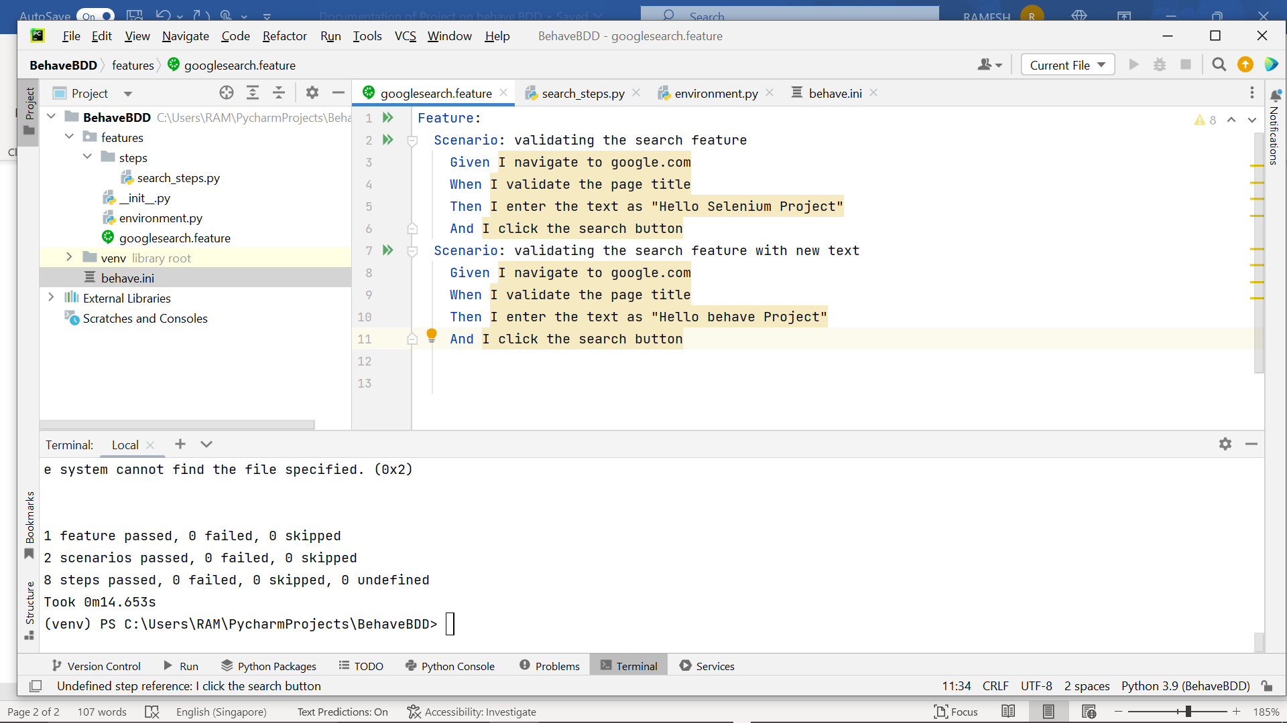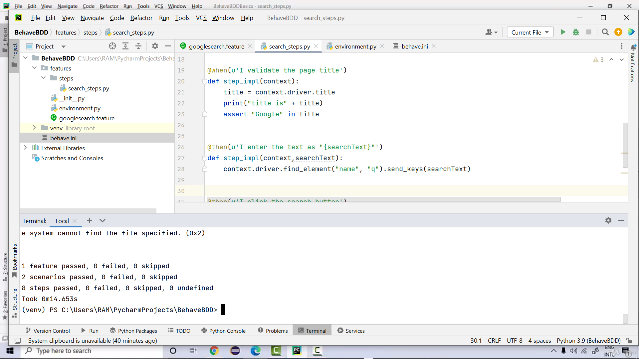
Instead of creating more scenarios, we can create an google_search_outline.feature in the feature directory
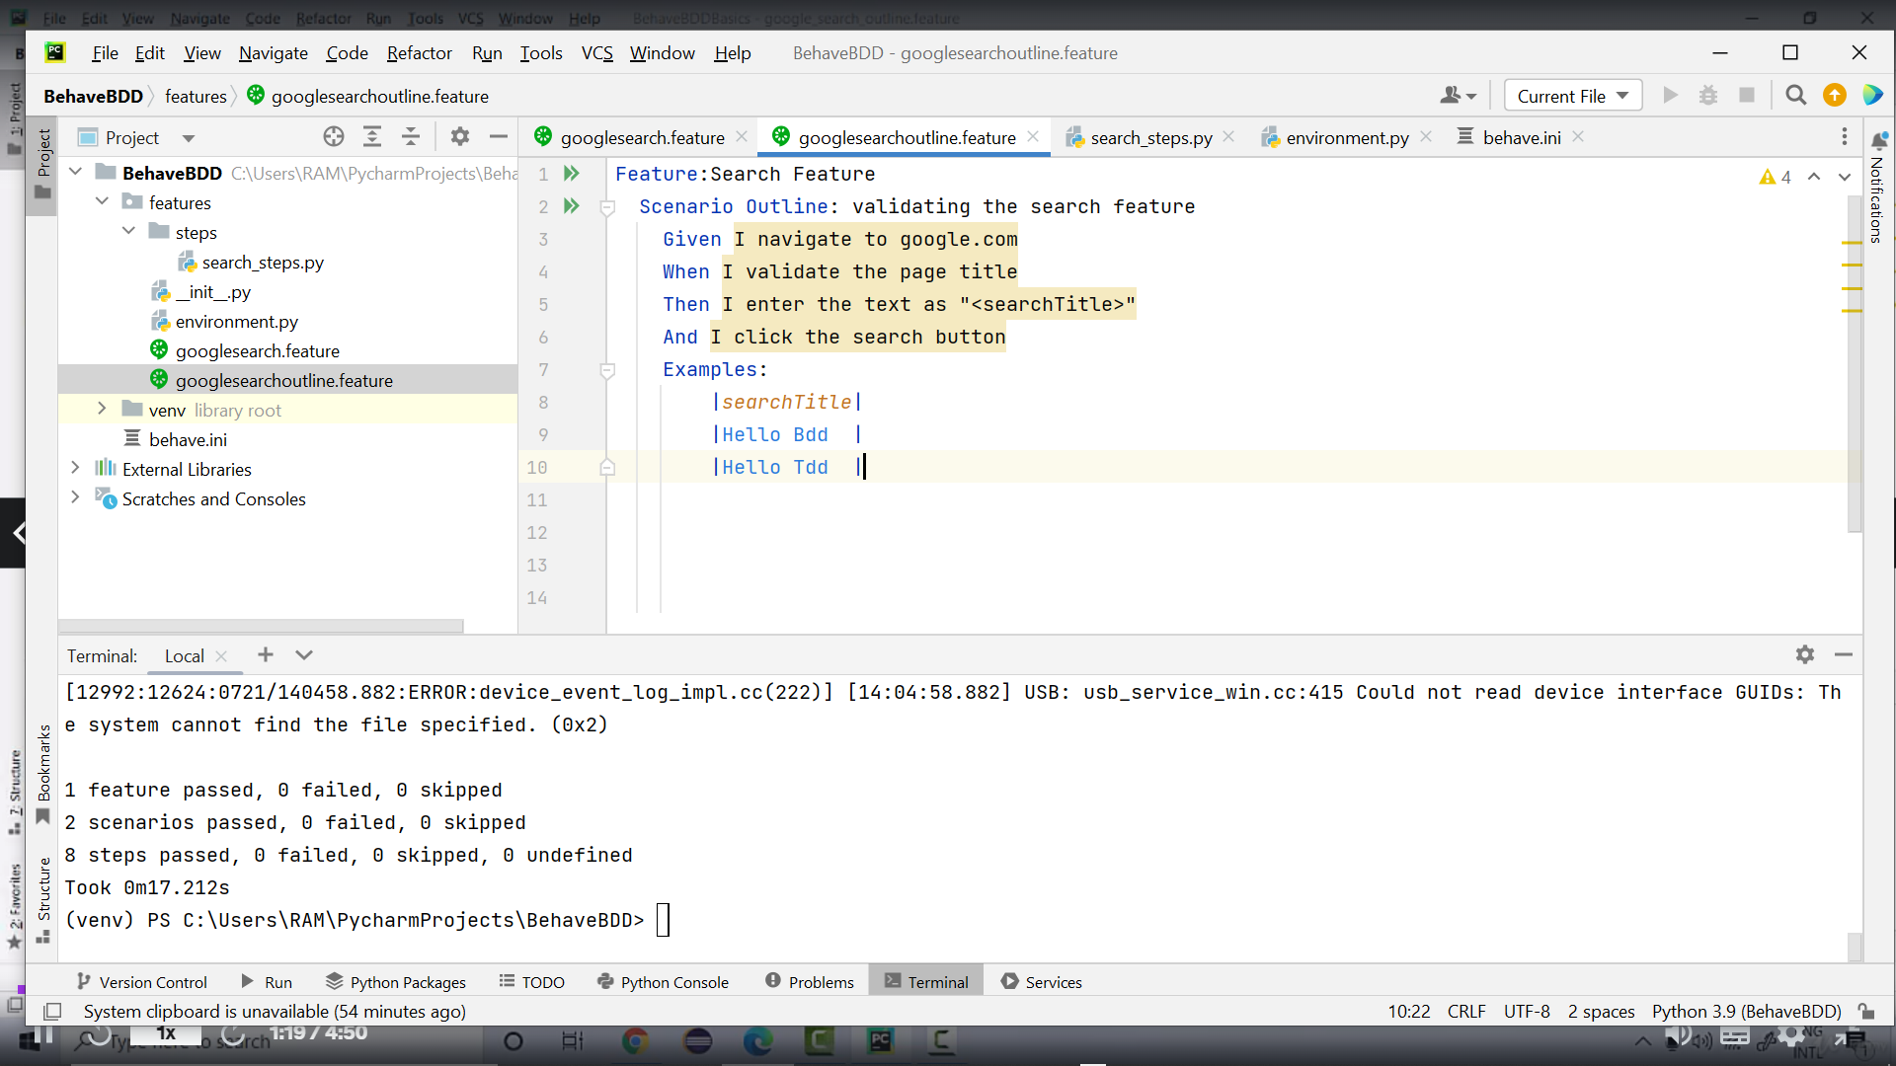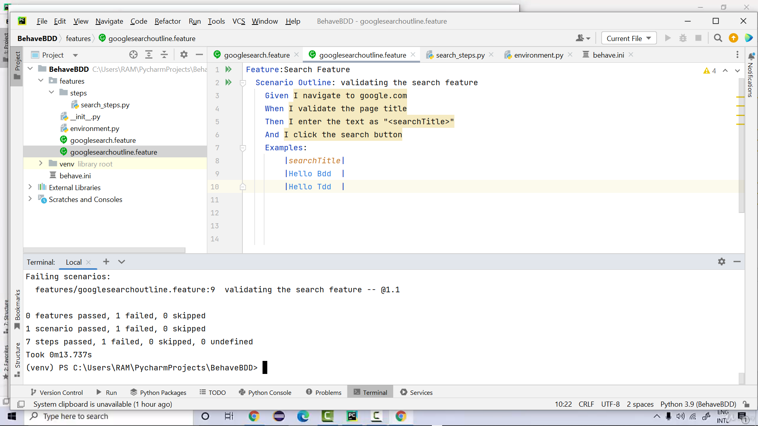
Background code:
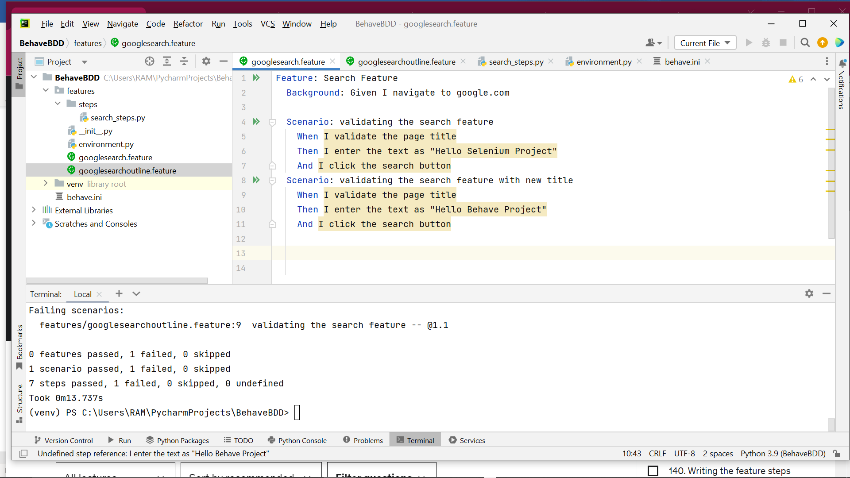
Generating allure reports:
Install allure-behave
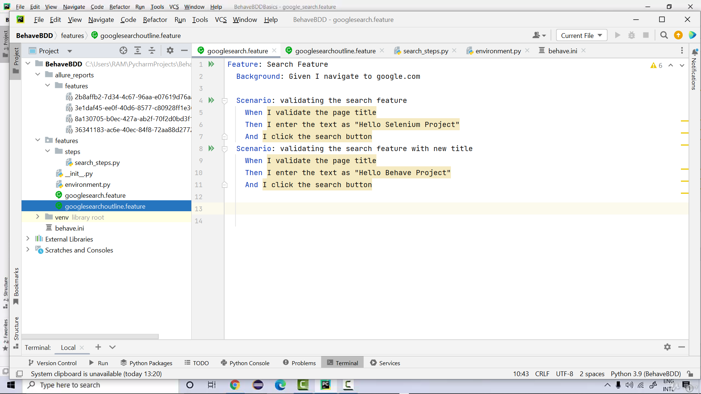
allure serve allure_reports
